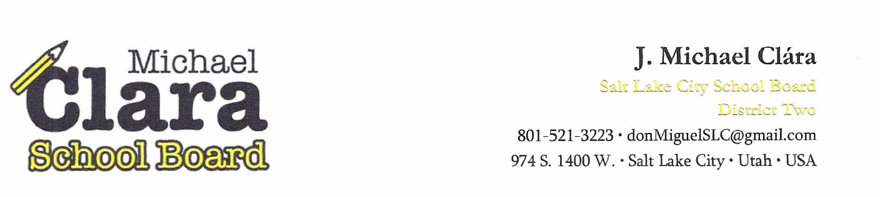

MEMORANDUM DELIVERED VIA ELECTRONIC MAIL
TO: Senate Education Committee & House Education Committee– Utah State Legislature
FROM: J. Michael Clára –Board Member, District 2
CC: President Niederhauser ▪ Speaker Hughes ▪ Senator Escamilla ▪ Representative Romero
▪ Utah State Auditor Dougall ▪ Superintendent Cunningham ▪ Business Administrator Roberts
DATE: 3 October 2016
SUBJECT: Misappropriation of the State Gang Prevention/Intervention Program Funding

Acting under the authority of my elected office, and in my official capacity as a member of the Salt Lake City Board of Education (Board), I am writing to members of the Utah Legislative Education Committees to express my alarm with what appears to be a colossal break down in the fundamental concept of local school board governance. While this problem has its ebb and flow, the current state of affairs has the potential to quickly escalate into a public health crises for Salt Lake City if the gang intervention program in our schools is not restored.
Over the past six months, in response to my requests, the Salt Lake City School District’s bureaucracy has provided me with scant or misleading information on the programs and finances designed to serve our most vulnerable student populations. During the months of July and August of this year, newly appointed Superintendent Cunningham was ignoring my emails. In some frustration, I submitted a GRAMA request for the outstanding information about the finances of the District.
On September 02, 2016 – I received a reply from the Superintendent’s Attorney (Kristina Kindl), advising that she will provide me the information on the finances of the District, after I pay the:
$337.50 dollar invoice included with her reply.
Attorney Kindl goes on to state that she is billing me at a rate of $45.00 an hour, she also adds that this does not include copying cost which will result in additional fees (see letter on following page).
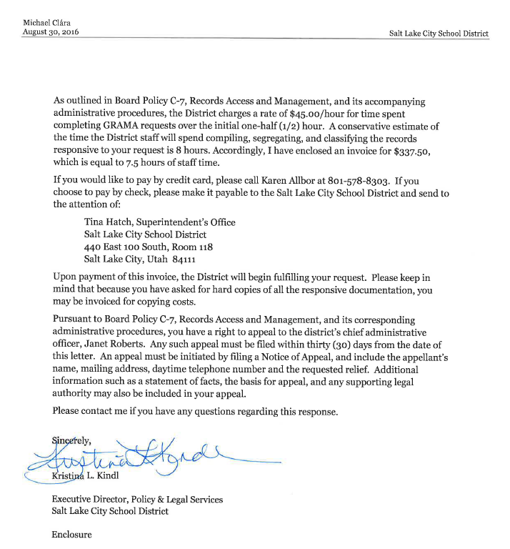
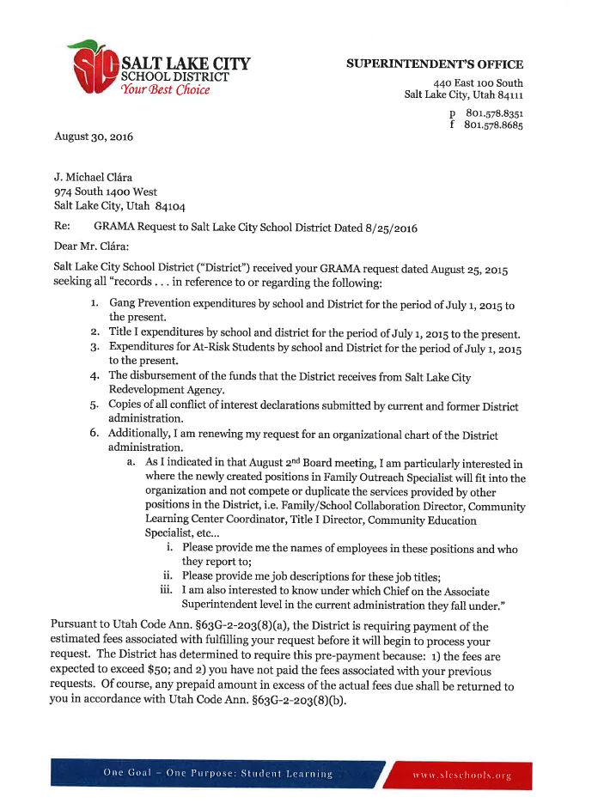
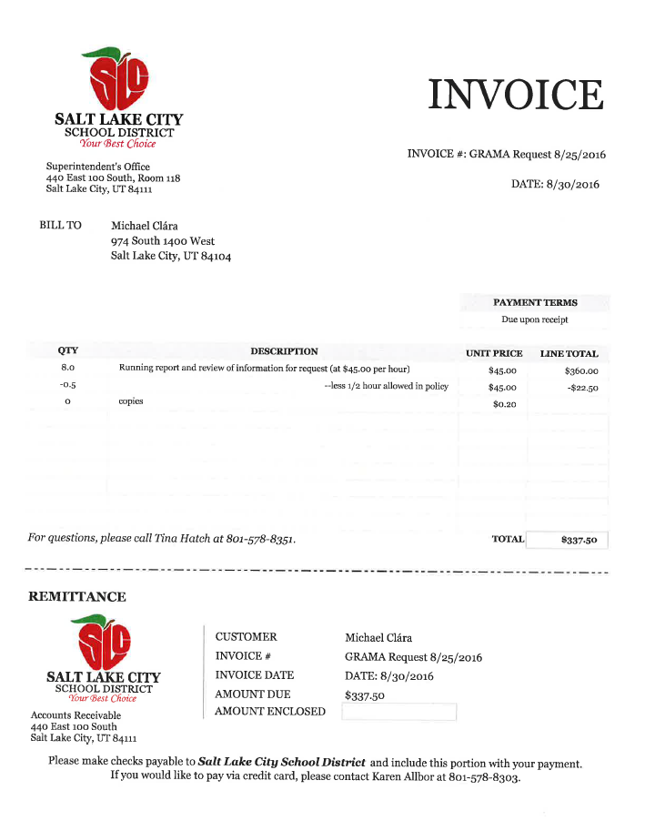

PUBLIC HEALTH CRISIS
The comprehensive gang model, as set forth by the U.S. Department of Justice calls for a community’s efforts to focus on the following when combatting gang violence:
- Gang Prevention
- Gang Intervention
- Gang Suppression.
The Salt Lake City Police Department does an outstanding job on the gang suppression aspect of this model. The intervention part has been coordinated by a public-private partnership with caseworkers imbedded in the schools. They then coordinate with law enforcement and other agencies to help students out of the gang lifestyle.
In response to multiple requests, in July of 2016, Superintendent Cunningham provided me a copy of the grant application (after it was submitted) and other information about the District’s current gang intervention program. The information she gave me stated that the District will have five gang intervention “advocates” at five different schools in the District for the 2016-17 school year. I passed on this information at community meetings and with parents prior to school starting. During the first week of school, I was informed by parents and local administrators that only one school had a gang intervention advocate on campus.
This is significant, in that these gang intervention advocates are the ones that students, educators and members of the community typically go to when there is talk of gang violence. They are also the ones who monitor the closely knit gang networks and work with school officials, other agencies and families to head off potential gang violence in our community. Moreover, they are an integral part of the process in helping students get out of gangs. Yet, based on the scant and fractured information currently at my disposal, it now appears that Business Administrator Roberts has single handily eliminated the intervention aspect of this model from the District and replaced it with a Social Studies elective (classroom setting) created by a teacher that works within the District. I also noted in the grant application, under the heading of “program assurances”, Business Administrator Janet Roberts states: “Filing of this application has been authorized by the governing body of the applicant”. As a member of the governing board, I have no knowledge of this application being presented or approved by the Board. On the contrary, I asked about the status of this application during this past budget process and it was not given to me until two months after Business Administrator Roberts signed it and turned it in to the State Office of Education. Additionally, I find no record where this was presented to the Board for approval.
Business Administrator Roberts also asserts that the District had in place a “Gang Prevention and Intervention Advisory Council” that provided “annual program evaluation, long range planning and evaluation.” Yet the page in the application where the members of this group should be listed is blank. I have since confirmed from multiple sources in the District office that no such committee existed. Furthermore, the application does show that a large portion of the gang prevention money is being diverted away from gang intervention and into a classroom setting.
Dr. Laurie Lacey (Title I Director) stated that Techniques for Tough Times (Social Studies elective) is “not a gang intervention program”. Additionally, parts of the application are missing required data. The sections that ask for goals, objectives and evaluations is also left blank. Colors of Success (Colors) has effectively provided the District with gang intervention services for the past decade. Speaking from a procurement standpoint, Colors is currently listed as the sole provider for gang prevention services. My question is, “what procurement process did the Administrator Roberts follow when she made the decision to divert funding away from the ‘sole provider’? In other words, it appears that Roberts changed the District’s gang intervention services in violations of the requirements in the state’s gang grant requirements and in violation of Utah procurement laws.
One of the responsibilities of Business Administrator Roberts is to “insure that adequate internal controls are in place to safeguard the District’s funds” Based on my observations over the past four years, the control and safeguards are either broken or just not adhered to within this District. Moreover, I believe the decision to eliminate gang intervention from the District is not only illegal but shortsighted and will have a reverberating negative impact on Salt Lake City’s westside communities. In the case of gunfire on neighborhood streets, we are told that violence gets passed on by cultural norms around retaliation and issues of “respect” in high-crime communities. To that end, a 2013 study of gang homicides in Boston and Chicago, determined that killings were driven by status-seeking, retaliation, and the organizational memory of a gang all of which are networked through socially symbolic behaviors. I ask you to consider the following crises at our doorstep:
On August 23, 2016 – A 16 year old was shot by two others in front of the Dual Immersion Academy, Charter School in my neighborhood. It is my understanding that neither the victim nor suspects attended that school. The location of this shooting was within three blocks of Parkview Elementary and Mountainview Elementary. I came upon the scene as the ambulance pulled away with the victim (see blog post picture).
On August 24, 2016 – Two other Juveniles were held hostage, pistol whipped and gasoline poured on them in Salt Lake City’s westside. While the police are reporting the suspects are from California, both victims and suspects are known by our students within our school District.
On September 5 to10, 2016 - I checked the Salt Lake City Police Watch log and these are the case numbers associated with incidents involving a gun or drive-by shootings over the past few days (does not include calls where shots were only heard): 16-133193 /16-132967/16-163309/16-164206/16-164141/16-164364/16-164079/16-165395/16-164185/ 16-167847/16-168137/16-172252/16-184562/16-183896/16-184845/16-184482. There was an aggravated assault with a gun at 1100 W. area of California Avenue which is two blocks from Mountainview Elementary School. Over the past weeks we have seen fights in various parts of Glendale once school is let out in the afternoon. Several of my neighbors have advised me that the police will show up sometimes an hour later, after they call.
This past week there was a gang incident at West High School (16-173317). Edison Elementary called the police to report gang actively (16-173196). Also this past week, there was a large fight at Glendale Middle School (16-172689). Another fright involving Glendale students was reported at 1300 S. and Concord area on that same day (16-172686).
I created the following display (photos I took) that depicts the aftermath of an incident that occurred this past Saturday at dusk, where revival gang members were shooting at each other where at least 15 children of elementary school age were in the area (three blocks from Franklin Elementary):
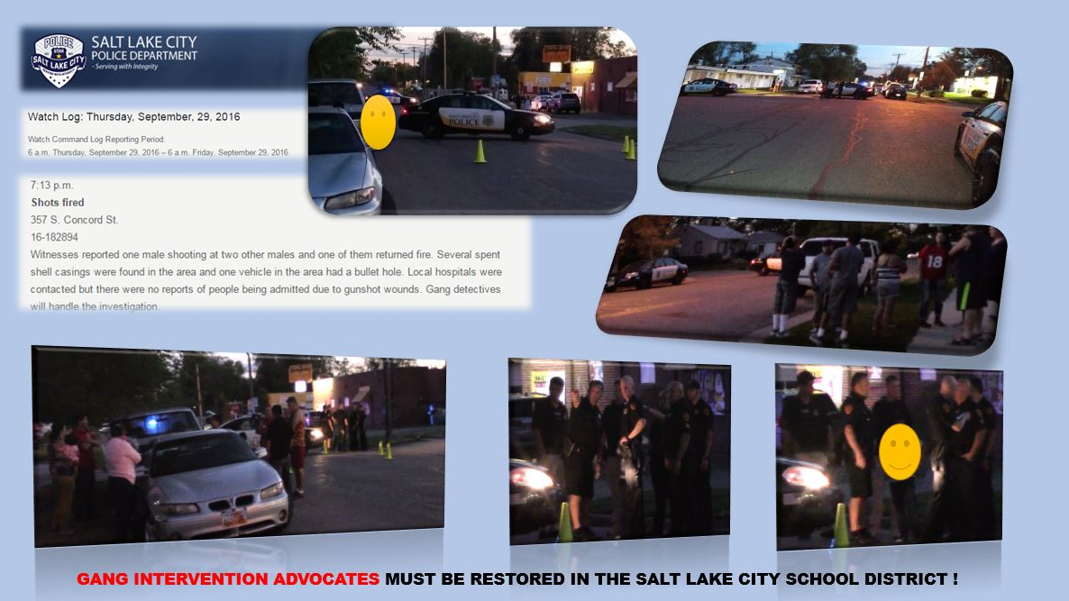
Consequently, I predict that Salt Lake City will spiral into a cycle of gang violence if we stay this course of neglecting the intervention part of the national model within our schools.
Relying solely on the police, has proven to be ineffective: Sociologist tell us, “…you can’t arrest your way out” of gang violence because it’s the people who are most embedded in the relatively small networks of violence that need to be reached through intervention efforts within their communities.
Several years ago, the Utah legislature clearly understood these concepts and adopted a framework wherein state funding was provided to combat gang violence within our communities. Yet that funding is not appropriately being spent within the Salt Lake City School District.
BACKGROUND
On April 5, 2016 - At the regularly scheduled Board meeting, I specifically requested that the Board look at student, police, community and gang intervention in a comprehensive manner within the context of budget development.
On May 16, 2016 – I met with Superintendent Cunningham and among other issues advised her of my concern for the manner in which District personnel were misappropriating state funding allocated to the District for gang prevention and intervention.
On May 17, 2016 –During a regularly scheduled Board meeting, I renewed my request for financial information on the gang prevention and for at-risk students.
On June 7, 2016 – Prior to the regularly scheduled meeting of the Board commencing, I once again asked you in your capacity of the Board’s Business Administrator, for information on gang funding as well as clarification on a $20,000.00 expenditure for the Salt Lake Area Gang Project. You consulted with Larry Madden who claimed to not have any information on the expenditure, but would check with one of his subordinates and get back to me.
On June 21, 2016 – During the regularly scheduled meeting of the Board, I once again, raised the issue of the status of the District’s gang intervention program. The Board president spoke to my request with a commitment to have the information provided to me. Administrator Roberts spoke to my concern and advised me that it was a grant from the state that she signed off on it, although she would not provide me any information in response to my questions. In that same meeting I asked about the details of RDA expenditures. I was told that the information I requested, would be provided.
On July 12, 2016 – I sent an email to Superintendent Cunningham advising her that I was not going to attend the so called “Board, small group meetings” about the District’s budget, as I believe this is how the District circumvents Utah Open and Public Meeting Act. In that same email, I renewed my requests for the following information on the finances of the District:
- Expenditures on Gang Prevention
- Expenditures of Enhancements for At Risk Youth
- Title I Expenditures
- Expenditures and classification of School bus routes
- Revenue and Expenditure of RDA funding from the City
- Expenditures of the on the University of Virginia Turnaround Program
“I cannot make an informed decision on funding if I do not have a clear picture on how the District is utilizing this particular category of state funding…Finally, I want to ensure that the Board has been informed about all available funding.

Last year we were told of the need to raise taxes by 1.5 Million and then in late November we are told of an additional ongoing 2 million dollars available in the budget. It is imperative that all information about revenue be disclosed to the Board during the budget process and prior to the Truth in Taxation hearing, not afterwards.”
On July 18, 2016- I once again met with Superintendent Cunningham and among other issues renewed my request for information on the status of at-risk student funding. In that meeting, I renewed my request for information on the finances of the District. I also renewed my objection to personnel changes occurring without Board approval. I also renewed my request for an updated organization chart of the District administration and departments.
On July 29, 2016 – I received a copy of the Gang Prevention and Intervention grant signed and submitted to the State Office of Education by Business Administrator Roberts and Chief Operations Officer, Larry Madden, back in May of this year. The proposal confirmed what I was being told, that Administrator Roberts and Chief Madden did indeed eliminate Colors of Success as the District’s gang intervention program. In my correspondence to the Superintendent I asked the following:
“…from a procurement standpoint, can you please advise me what process Administrator Roberts and Chief Madden followed in order to utilize the services of a teacher from East High and her program, Technique for Tough Times in place of Color of Success? My records indicate that Colors of Success is the District’s designated “Sole Provider” for Gang Prevention programs within the District?
I have as of yet to receive a response from the Superintendent.
On July 31, 2016 – I sent Superintendent Cunningham correspondence that she acknowledged receiving, yet as of this writing, has not responded to my requests in that email. I here mention one of them:
In light of the fact that I have received multiple reports of administrators utilizing District resources in order to generate income for their private sector business, I would request copies of all “conflict of interest” declared by employees of the District as required by state statute: “An employee shall declare a potential conflict of interest…”
On August 2, 2016 – During a regularly scheduled meeting of the Board, I once again renewed my request for details on the finances of the District and a current organizational chart of the departments and personnel on the District level.
On August 3, 2016 - I did receive scant information (four pages) on Title I expenditures. However, it is not to the level of detail that I require in order to make decisions on the finances of the District.
On August 25, 2016 – I submitted a GRAMA request for information on the District’s gang prevention program as the information that the Superintendent provided me in July was misleading and inaccurate.
On September 02, 2016 – After receiving no response from the District (considered a denial under GRAMA), I sent a GRAMA appeal letter to Janet Roberts who serves as the District’s GRAMA appeals officer. Later that day, I did receive a reply from the Superintendent’s Attorney (Kristina Kindl) informing me to pay the District $337.50 dollar if I want to review the financial records of the District.
On September 10, 2016 – I received a letter from the Boards Business Administrator, Janet Roberts advising me that my GRAMA appeal letter to her is “moot”. Ms. Roberts then duplicitously exhorts me as follows:
…Please keep in mind that as an elected board member, you can request district information through the informal process provided for in Board Policy B-1: Board of Education Legal Status, Responsibilities, and Ethics. This Policy outlines the process through which board members can receive information necessary for the performance of their elected duties, and receive such information free of charge, and may, if appropriate, provide you with information that is not available to the general public.
You will note that on multiple occasions, I did indeed “request district information through the informal process”. This kind of organizational schizophrenia is so common in this District that it is now normalized behavior.
On September 12, 2016 – Two other Board members and I met with Dr. Cunningham about her recent practice of ignoring my emails and requests for information. In this meeting, she acknowledged that Business Administrator Roberts signed off on the gang prevention grant application in spite of the fact that several of the assurances required by the grant were not met by the District. She also disclosed that the District has only one part-time gang intervention specialist in place. The three Board members in the room advised Dr. Cunningham that one part-time advocate for the entire District is not at all sufficient, she committed to work on that and would get back to us. Dr. Cunningham further stated that I had not been provided a current organizational chart of the District because there is not one that accurately reflects the current structure of departments and administrators, she also confirmed my suspicion of duplicate, competing and redundant positions do indeed exists within the organization. In order to determine to what extent inefficiencies are occurring, she said she would need to hire an outside company to conduct and organizational audit. I objected to spending money on yet another organizational audit if we are going to ignore the results and recommendations as we are doing with the Human Resources Department audit currently in our possession. She also revealed that many of the positions in the District do not have job descriptions and none of the administrators have evaluations in their personnel file.
I submit, this is the result of former Superintendent McKell Withers and current Business Administrator Janet Roberts, bypassing the Board in the approval process of new hires as prescribed by state law. Dr. Cunningham is perpetuating the same bad behavior by placing people in new positions within the District absent the checks and balance that state law has endowed the Board with. The continuation of bad behavior on the part of the administration translates into more tax dollars being used on fixing problems and not on educating our students. Prior to leaving the building, I hand delivered a second GRAMA Denial Appeal to Business Administrator Roberts.

Following the meeting with the Superintendent, I went to the Utah State Board of Education building and met with Ms. Ann White, Director of Student Advocacy Services. I reported to her, the deceptive manner in which the gang prevention grant application was submitted to the state office of education.
On September 16, 2016 – I received my second denial of appeal letter (see attached) from Business Administrator Roberts wherein she denies my fee waiver appeal for the following reason:
“You are also seeking a fee waiver based on your belief that "releasing the records primarily benefits the public rather than a person." You have provided no evidence that the release of these records would primarily benefits the public, rather your assertion is based upon the fact that you are an elected board member. If every elected public official was entitled to have his/her GRAMA requests fulfilled free of charge, the statute could have easily included that language. However, the statutory language does not include an exception for every elected public official, nor does the statute even require the district waive fees in instances in which the release would primarily benefit the public, it merely encourages it.”
I include the entire denial letter in this correspondence because it demonstrates the disdain that Ms. Roberts has for the office that I hold. I believe it also displays her conviction that she is under no obligation to honor my requests to view the finances of the District.

SEE
NEXT
PAGE

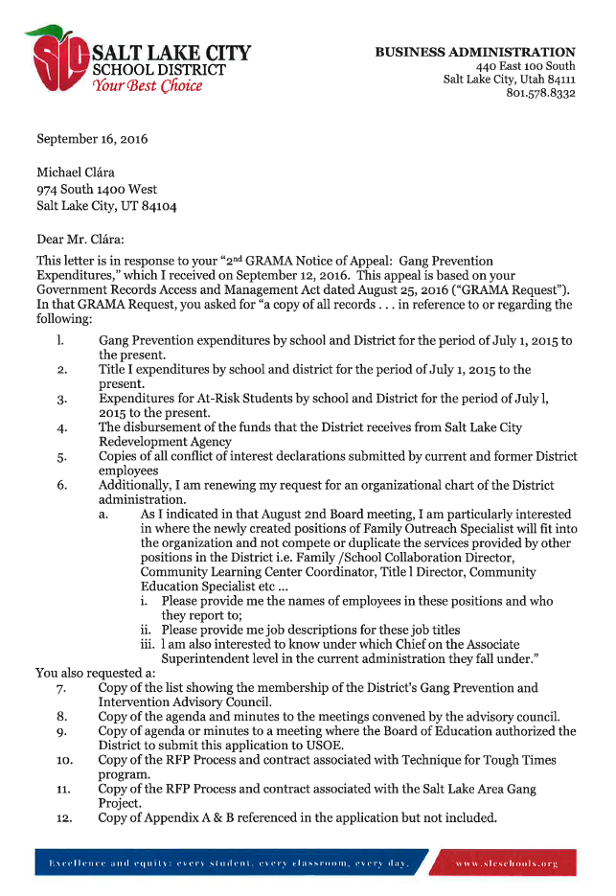

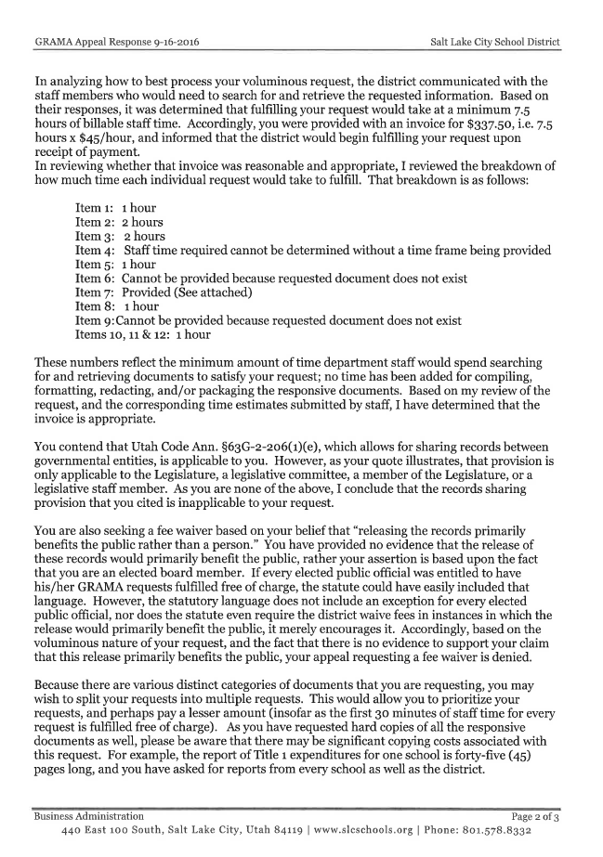

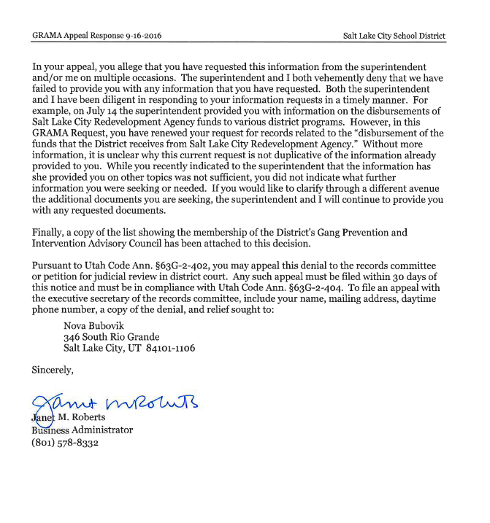

GOVERNANCE IN EDUCATION
As you are aware, the Utah Constitution specifically defines a school district as a "political subdivision" of the State of Utah. Moreover, The Utah Constitution vests "general control and supervision of the public education system" in the State Board of Education. The Utah Legislature has defined "general control and supervision" to mean "directed to the whole system."
Accordingly, the State Board of Education has the authority to establish rules and minimum standards regarding qualification and certification of teachers, graduation requirements, school accreditation, school building sites, school lunch programs, and student accounting requirements. Each of these responsibilities relates to the management of the school system in the state as a whole. Seeing that Superintendent Cunningham is from Arizona, she may not be aware that in contrast, local school boards exercise a myriad of responsibilities independent of the State Board of Education:
- The Salt Lake City School Board receives revenue from local property taxes, state grants and Federal monies.
- The Salt Lake City School Board may levy taxes pursuant to state and local law to fulfill its obligation to provide for the schools within the District.
- The Salt Lake City School Board is empowered to collect property taxes for debt service and capital outlay.
- The Salt Lake City School Board has the obligation to finance the basic school program in order to locate, and maintain elementary, secondary and vocational schools.
- The Salt Lake City School Board has the legal power and duty to do all things necessary for the maintenance, prosperity, and success of the schools and the promotion of education to exercise all powers given by statue.
- The Salt Lake City School Board is empowered to determine what things are detrimental to the successful management, good order, and discipline of the schools and the rules required to remedy these conditions by the empowerment of the following duties:
  - Formulating and interpreting Board policies
  - Employing by contract the superintendent, principals, teachers, or other executive officers and set salary schedules therefore.
  - Requiring and evaluating reports from the Superintendent on the educational program and financial status of the schools.
  - Adopting such rules, regulations, and bylaws as the Board may deem proper.
  - Having District fiscal accounts audited at District expense by an independent auditor and filed with the State Superintendent as required by law.
  - Receiving bequests and donations or other monies or funds that are made for educational purposes.
  - Close the schools or suspend operation if necessary.

I have taken the time to list the powers and duties granted to a local Board of Education, as it serves to highlight the absurdity of Superintendent Cunningham’s refusal to provide me information that I require in order to fulfill my statutory responsibilities. I have already exposed numerous instances of financial improprieties within the District. Superintendent Cunningham’s latest actions are an example of what I file under the category: The cannibalization of public education
This is where a Superintendent will use my neighbors hard earned tax dollars to hire a full-time attorney and Public Information Officer that will conspire to conceal information and finances from the very person that those tax payers elected to represent their interest on the Board.
In spite of a mandate to do so, the Utah State Office of Education is not monitoring the expenditures of state funds and neither is the local Board of Education. Make no mistake, those that run this local school district are operating in the absence of any type of local or state oversight. In other words, the Superintendent and her administration are accountable to no one on how they expend the District funds. The current state of affairs should not be allowed to continue.
UTAH OPEN AND PUBLIC MEETING ACT
Here is yet another example of the cannibalization of public education. Last month the Superintendent’s attorney proposed a change to Board policy on how items on the agenda are to be handled:
The board member MUST…contact the superintendent to notify…her of the board member’s concerns with a consent or action item [on the agenda] at least twenty-four (24) hours prior to the scheduled board meeting
Clearly, that requirement is in direct contradiction to the legislative, “Declaration of Public Policy”:
It is the intent of the Legislature that the state, its agencies, and it political subdivisions:
- take their actions openly; and
- conduct their deliberations openly
Superintendent Cunningham and her attorney must not be aware that in Utah, not only are the Board’s “actions” to be conducted “openly” but so should our “deliberations”. Hence, requiring me to submit my concerns about items on the public agenda, to a subordinate, 24 hours prior to the meeting, does NOT make for open deliberations.
I should here point out, that at our August 2, 2016, Board meeting, I sent the Superintendent a request to move the purchasing report and the human resources report from the consent agenda to the action agenda. Additionally, I did pose questions via email about items on both reports. The Superintendent acknowledged receipt of my email and then in the public meeting denied receiving any questions from me. The following day, I sent her a copy of her acknowledgement email and I asked her for an explanation as to why she was not truthful in the public meeting, as of this writing, she has not replied.
Do you see the dilemma? It matters not, in what format or when I ask questions or request information, I typically do not receive a response. This has the effect of disenfranchising the citizens of Salt Lake City’s westside as their elected representative is consistently denied information about the finances of the District. This behavior on the part of the administration also serves to break down the local level of checks and balances.
Moreover, their actions and obstacles divest me of my role as an elected official to exercise my part of the procedural safeguards which are designed to protect the finances (taxes) of the District. The current state of affairs in the Salt Lake City School District is manifestation of what Deseret News columnist John Florez described:
In their orientation, new board members are told they are supposed to get along with their colleagues — the family — and remember they represent the corporate body, and cannot speak for the board.
The bureaucrats have created a maze of rules created to stifle any dissent that would disrupt the status quo…
Once elected to the board, many are co-opted and intimidated by the bureaucratic professionals who know best; they quickly comply with the myriad administrative rules created to protect the corporate body.
Many do not see or exercise their responsibility of overseeing their school district. In doing so, they compromise the taxpayers’ interest.
The result is an insulated school board that gives the appearance of leadership while succumbing to the seasoned administrators who make sure nothing happens…
School boards have mastered the art of ignoring even legislators. They are fastidious about following process and custom…
PUBLIC RELATIONS
Unfortunately, Superintendent Cunningham has been indoctrinated in her predecessor’s methods; In our last Board meeting, she advised us of her desire to hire Love Communication ($43,000.00) to help “improve the District’s image”. I am of the opinion that telling the truth is more cost effective. I objected to spending money in this fashion and advised the Superintendent as follows:
...What I said two years ago on a similar situation is instructive. In response to another instance where Heather Bennett and McKell Withers attempted to reduce viable solutions to public relations counter-offensives, I stated the following:
Board member Michael Clara also said he feels it's not a good use of tax dollars. "We're here to educate children, not worry about our image, and that could have been solved had they dealt with this honestly in the beginning," Clara said.
He called it "devious" for the district to put out a request for proposals for $1 less than what's required for full board approval. He said he wasn't aware of the request until he heard about it unofficially, not from the district.
Superintendent Cunningham stated that the District’s Public Information Officer does not have the time to manage public relations issues facing the District. Yet the administration has the time, energy and resource to monitor the activities of Board members. In the fall of 2014, I was made aware that the Superintendent’s Attorney had issued over a dozen GRAMA requests to other elected officials in an effort to track my activities. I submitted a GRAMA Request to ascertain why District resources were being utilized to monitor my activities. I obtained a copy of an email exchange between Jason Olsen (PIO), McKell Withers (Superintendent) and his personal attorney Kristina Kindl wherein my asking questions in a recent Board meeting was described as “repugnant” and a list of tactics to “control” me and silence my voice was outlined. The action list included the following:
- Letter of Reprimand
- Censure
- Change board meeting procedures to limit his speaking time
- Declaring any discussion as not on the agenda and out of order and stopping him immediately
- Have him removed from the meeting
- Public letter demanding an apology
- Obtain letter of support from the board for superintendent and board administrator
- Obtain letters of support from the schools for the superintendent
- Obtain letters of support from the community for the superintendent
I also discovered an email where the Director of External Communications, Michael Williams and the Superintendent were discussing my church activities and ecclesiastical responsibilities: “…he is on the High Council…left of the Stake President 5 individuals down…” Withers replied “…it was my understanding that he was on the High Council somewhere, sounds like we know where now.” This exchange is significant, in that it further illustrates how the resources of the District are used against me in my capacity as an elected official and not used to provide our children with the quality of education that they deserve.
TEXAS REGENT
A recent incident in Texas has several parallels with what is happening here in the Salt Lake City School District. Similar to Superintendent Cunningham, University of Texas System (UT) Chancellor McRaven has utilized several procedural methods to withhold information from UT Regent Wallace Hall. Late last year the Texas Attorney General determined the following:
Texas Attorney General Ken Paxton sharply rebuked the administration and board of regents of the University of Texas Tuesday, granting a sweeping ruling in favor of UT Regent Wallace Hall and stating that a recent board decision limiting regents’ access to records violates state law…
Paxton’s opinion is the latest development in an ongoing and increasingly entrenched fight between UT Chancellor William McRaven, his loyalists on the board and Hall, who has worked for years to uncover the role of political favoritism in the UT admissions process…Earlier this year… Hall won a simple two votes to get access to the records, board members who are devoted to keeping UT’s secrets secret decided the bar is too low for regents to review documents pertaining to the very institution they pledge to serve. So the board changed the rules to require that a majority of members support an individual regent’s request for internal documents if those documents cause UT’s chancellor or chairman “concerns”. On its face, the new rule is bizarre. What sort of Potemkin board would emerge if a regent couldn’t ask for material that concerns the administration. The scrutiny of board members should concern the administration. That’s what boards are for. Paxton saw this instantly.
“We believe this rule violates state law by imposing a substantive barrier to a regent’s right to access information he believes necessary to fulfill his regental duties,” Paxton wrote.
None of this is any surprise. Or it shouldn’t be. A long body of opinion from past attorneys general confirms this is the law.
“A member of a governing body has an inherent right of access to the records of that body when requested in the member’s official capacity,” states one well-established opinion.
REMEDY
When a school administration is allowed to act in an unchecked and incoherent manner, it is the students from communities such as mine that suffer the most. I want the members of the Legislative Education Committees to be aware of the current state of chaos in Salt Lake City. The current school administration is accountable to no one on how they are expending funds designed to meet the educational needs of our most vulnerable students. I am asking members of the legislature to help me explore ways in which we can restore order to this chaos, so that the public education system in Salt Lake City can fulfill its purpose. In conclusion, I echo the insight of John Florez:
The Utah Legislature reaffirmed that local school board members have the obligation to speak out to ensure their constituents’ interests are represented. To do less abdicates their responsibility to their constituents who entrusted them with overseeing one of the most vital institutions of our society. School boards should be more than showcases; rather, they should be public forums where education policymaking is vigorously debated and is transparent and accountable to the public.
Local boards now allow for everyone and no one to be responsible for the management of education and hide behind the regulations they have created to avoid responsibility. The passage of HB250 makes it clear each local school board member has the responsibility to assure our schools prepare our children to succeed in the ever-changing world they will face. The new law also makes it clear local taxpayers must make sure their elected local board member’s loyalty is to them, not the bureaucracy.

Utah Administrative Code Rule R277-436 Gang Prevention and Intervention Programs in the Schools
Notwithstanding a local school board's status as a body corporate, an elected member of a local school board serves and represents the residents of the local school board member's district, and that service and representation may not be restricted or impaired by the local school board member's membership on, or obligations to, the local school board. Utah Code § 53A-3-401(5)
“Criminologists and politicians have taken to referring to gun violence as a “public health issue.” This is a roundly good thing, since studies suggest that when people are primed to thinking of violence as a disease rather than as a “monster,” they’re more likely to recommend trying to improve the economy or provide better health care than build bigger jails or put more cops on the street”. See Gun Violence Is Like an STI in the Way It Moves Between People by Drake Baer
Michael Clára GRAMA request to Superintendent Cunningham – Gang Prevention Expenditures 08/25/16
Kristina Kindl letter to Michael Clára – Request to Salt Lake City School District 09/02/16
U. S. Department of Justice –Bureau of Justice Assistance –Office of Juvenile Justice and Delinquency Prevention
Superintendent Cunningham Weekly Report – July 21, 2016
Gang Prevention and Intervention 2016-2017 Proposal to the Sate Office of Education
Ibid
Diverting Gang Prevention- Intervention Funds? - Michael Clára YouTube Channel https://youtu.be/xrGQJeTGyh0
Utah Code §63G-6a-802 Utah Procurement Code
Utah Code §53A-3-303 Duties of Business Administrator
American Sociology Review: The Corner and the Crew: The Influence of Geography and Social Networks on Gang Violence by Andrew V. Papachristosa
Juvenile In Serious Condition After SLC Shooting – Salt Lake Tribune 08/23/16
SLC Police: Two Teens Kidnapped, Tied Up with Weed Eater Wire –KUTV NEWS 08/24/16
A recent study found that 70 percent of all nonfatal gunshot injuries happened within a network of people accounting for under 6 percent of the Chicago’s population from 2006 to 2012. See Social Science Medicine: Tragic, but not random: The social contagion of nonfatal gunshot injuries by Andrew V. Papachristosa, Christopher Wildeman, Elizabeth Roberto
How the Block You Live on Affects Your Shot at Success by Drake Baer
Utah Code§53A-15-603
Salt Lake City Board of Education Meeting – Video 04/05/16
Salt Lake City Board of Education Meeting – Video 05/17/16
Salt Lake School District –Purchase Report 05/03/16
Michael Clára email to Superintendent Cunningham – Board Budget Meetings 07/12/16
GRANT APPLICATION: Gang Prevention and Intervention 2016-2017 Proposal to USOE
Board Policy F-2
Utah Code §63G-6A-802
Notice of Proposed Sole Source Procurement – Request # 000958
Utah Administrative Code R477-9-3 Conflict of Interest
Salt Lake City Board of Education Meeting – Video 08/02/16
Dr. Cunningham Weekly Report to the Board
Supra note 3
Supra note 4
Janet Roberts letter to Michael Clára responding to GRAMA Appeal 09/08/16
Michael Clára GRAMA Notice of Appeal to Janet Roberts 09/12/16
Janet Roberts letter to Michael Clára –GRAMA Appeal –DENIED 09/16/16
Utah Const. art. XI §1
Utah Const. art. X §3
Utah Code §53A-1-401(1)
Utah Code§53A-1-402(1)
Utah Code §53A-3-402 [listing seventeen specific responsibilities of local boards];Nevertheless, there is a synthesis between the two Boards which comes from the Utah Legislature itself: "Basic responsibility for operation of the public school system of this state has been delegated by the Legislature primarily to local school boards, subject to general control and supervision by the State Board of Education."
Supra note 6
Utah Code Ann. § 53A-16-104,
Utah §53A-17a-135.
Utah Code §53A-3-402
Beard v. Board of Education, 16 P.2d 900 (Utah 1932)
Ibid & Salt Lake City School District- Board Handbook & Board Policy B-1
i.e. expenditures, organization chart, conflict of interests statements etc.
Notice of Public Meeting – Salt Lake City Board of Education 09/06/16 – Agenda Item: D-1(b) B-2, School Board Meeting [Exhibit D1b]
Utah Code §53-4-102
Michael Clára email to Superintendent Cunningham – Integrity 08/02/16
School Board Members Must Speak Up – John Florez, Deseret News 10/02/15
Salt Lake City Board of Education Meeting – Video 09/06/16
After Tossed Lunches, Utah District Eyes $49,999 PR Hire, Salt Lake Tribune 02/19/14
Kristian Kindl GRAMA Request to multiple elected officials (i.e. Governor, Select members of the legislature, Salt Lake City Council etc.… 09/18/14
Jason Olsen email to Withers, Kindl and Williams – Last Night’s Meeting 03/19/14
Mike Williams and McKell Withers email exchange 03/25/13
Attorney General: University of Texas Board Rules Violates State Law, Block Access to Information – Dallas Morning News 06/16/15
Notwithstanding a local school board's status as a body corporate, an elected member of a local school board serves and represents the residents of the local school board member's district, and that service and representation may not be restricted or impaired by the local school board member's membership on, or obligations to, the local school board. See HB 250 (2014) & Utah Code §53-3-401
School Board Members Must Speak Up – John Florez, Deseret News 10/02/15

