Michael Clara’s response to the McKell/Swett memo that was distributed at the 01-22-13 Board Meeting
Items in red are the original bullet points
Items in black are Michael Clara’s responses

November 2012 Official Ballot for all school board elections in Salt Lake County (Canyons, Granite, Jordan, Murray, and Salt Lake) were posted as precincts
In 2012, the ten-year redistricting had just occurred and there was a significant change in the school board boundaries.

The voting precincts in Salt Lake County were also realigned and re-numbered with a new sequence. The single digit numbers started in west Salt Lake City.

Voters were consulting their voter registration cards and were taking note of their new precinct numbers and where they resided etc..

In the fall of 2012 –The County Clerk published the sample ballots. I was listed as the candidate for Precinct 2.

Several voters in my neighborhood informed me that they could not vote for me because they did not live in voting precinct 2. Voting Precinct 2 is one of eleven voting precincts in my district. I explained that “if I am on your ballot, you can vote for me”.

At the time, several voters saw and read news reports that redistricting had caused more school board representation to happen on the westside. Some voters thought this happen by having us represent individual voting precincts:

“The vision, steered by new District 2 City Councilman Kyle LaMalfa, is to expand west-end representation and to diversify the school board. He also hopes the move eventually will give voice to the area's wide swath of ethnically diverse students.” (Will new SLC school District boundaries boost west-side focus?, Salt Lake Tribune – 04/02/12)

“After a redistricting process that extended two Salt Lake City school board district boundaries into the west side, four seats are up for election on Nov. 6. District 1 and District 2 (both on the west side) are on the ballot along with District 7 and newly extended District 5.Two of the city's seven school district boundaries were recently stretched into west-side neighborhoods as part of the redistricting mandated by the 2010 census. That means residents spanning Glendale to Rose Park now have a shot at four west-side seats, although only two will be on the ballot for this year's election” (Salt Lake City School District rivals from 2004 in another showdown, Salt Lake Tribune -10/20/12)

The map I had obtained from the County Clerk’s office shows me as a candidate for DISTRICT 2 as do maps that were published by SLC and the County Clerk.

I called the County Clerk’s Office and spoke to Pamala Tueller and asked her why I was listed as the candidate for Precinct 2 as opposed to District 2.

She said that State Law dictated that they use the term Precinct and that I should take it up with the Lt. Governor’s Office.

I called the Lt. Governor’s Office and spoke to Mark Thomas. He told me he would look into it.

The following day he called me back and said that the County Clerk’s Office should be using the term DISTRICT as per Utah Election Code 20A-14-201 states in part:

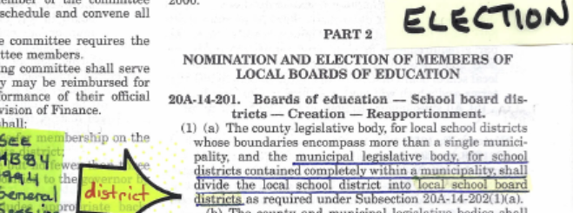

He said that the Lt. Governor’s Office did not have jurisdiction to make the changes but he would talk to Sherry Swenson. He called me back that day and said that Sherry advised him she was not going to change anything.

I also called Carol Leer at USOE and she referred me to Utah Election Code 20A-14-201 which is shown above and 20A-5-303 which defines a Precinct.

I emailed Sherry Swenson and asked what state law she was following that told her to use the term precinct. Instead of pointing me to a reference in state election code, she quoted web pages:

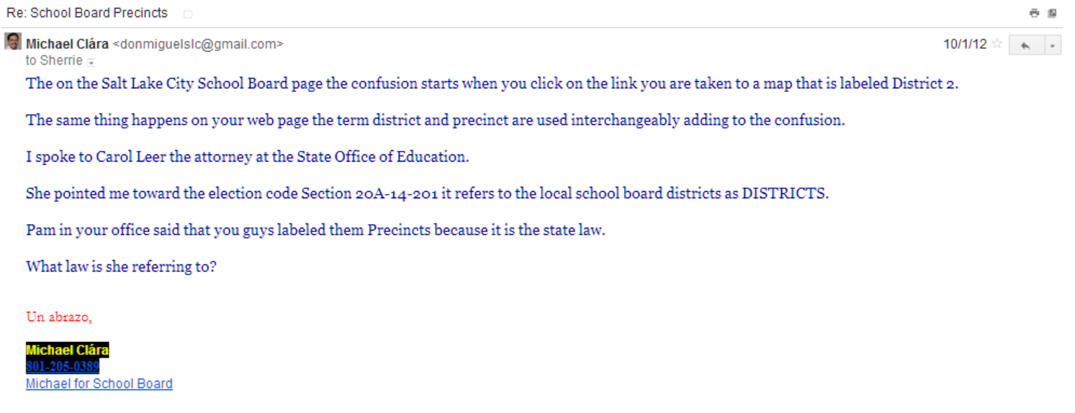
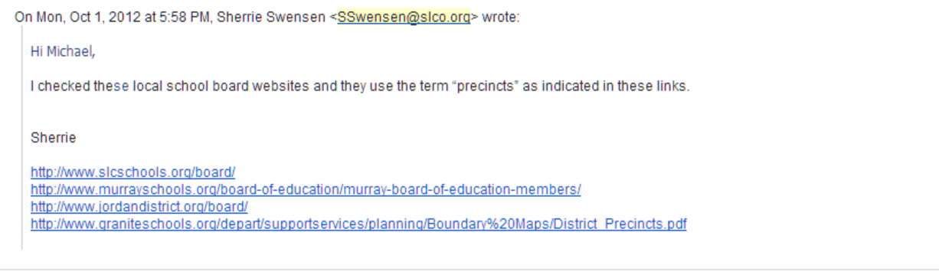

On Tuesday October 2, 2012 – I brought this issue the attention of Vice President Heather Bennett and Superintendent Withers; they said they would look into it.

On October 16th, 2012- I sent the following email to the County Clerk’s Office:

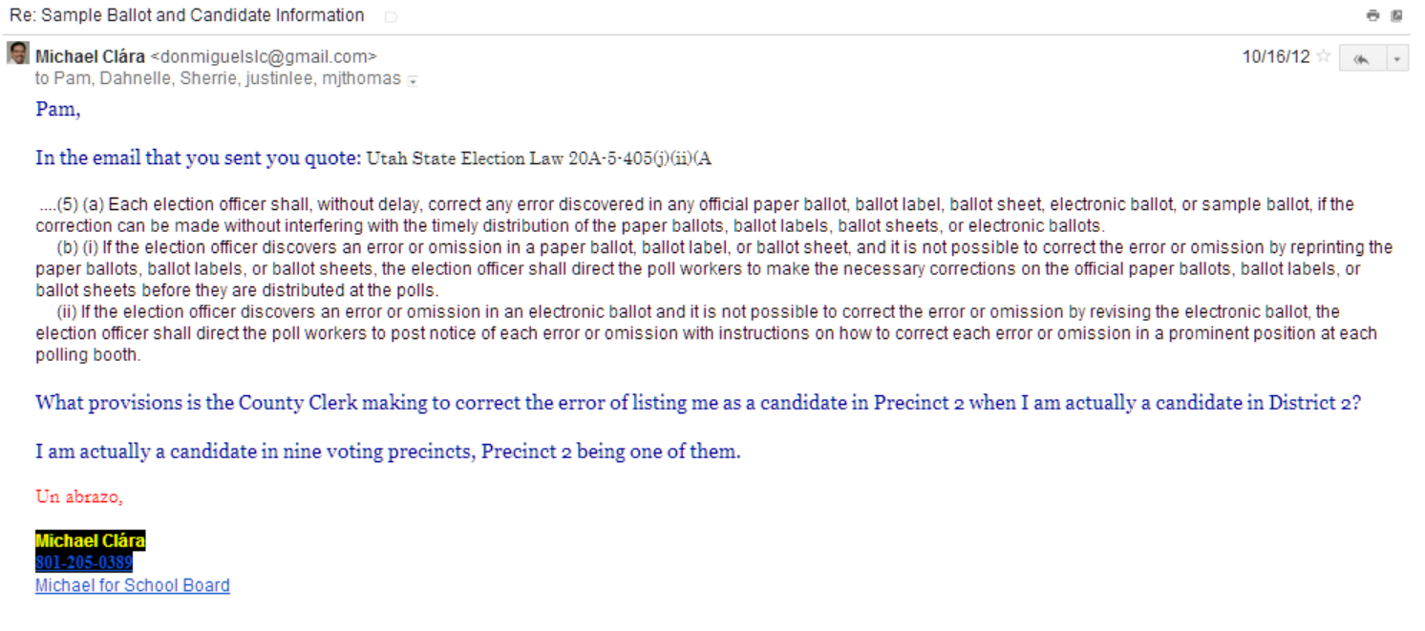

I received a response from Dahnelle Burton-Lee, Chief Deputy:

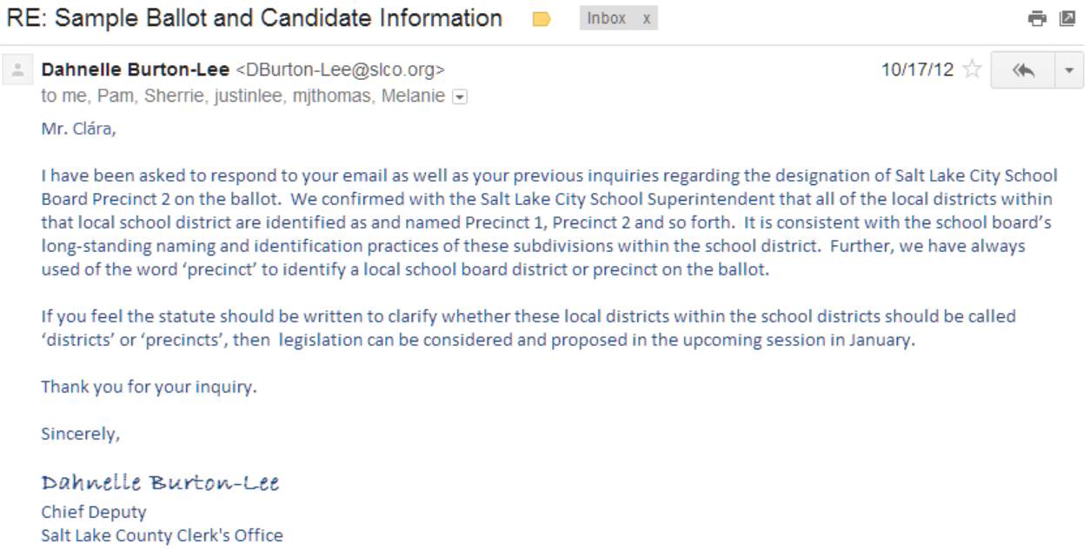

She states the following: “IF YOU FEEL THE STATUE SHOULD BE WRITTEN TO CLARIFY WHETHER THESE LOCAL DISTRICTS WITHIN THE SCHOOL DISTRICTS SHOULD BE CALLED ‘DISTRICTS’ or ‘PRECINCTS’ THEN LEGISLATION CAN BE CONSIDERED AND PROPOSED IN THE UPCOMING SESSION IN JANUARY”

I did just that. The Senator I spoke to, read the statue almost in a glance and said that there is no clarification needed. The law (20A-14-201) is clear as it stands: “…shall divide the local school district into local school board districts…” He then added: “a designated group of ‘precincts’ compose the local school board district, just as it happens for his district, where is the mystery in that?”.
Board member representation areas were called ‘municipal wards’ in the 1950s and 60’s and have been referred to as “precincts” from the 1970s until today
There is no question that various terms have been used in the past century. MUNICIPAL WARDS was used in 1953 to describe the areas we currently represent, that was later changed to PRECINCT:

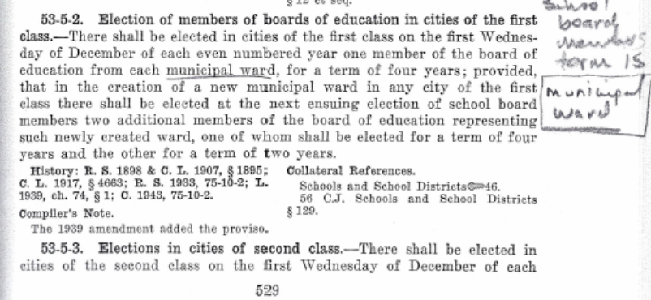

1953 UTAH CODE 20-3-2 Volume 3 Page 25:

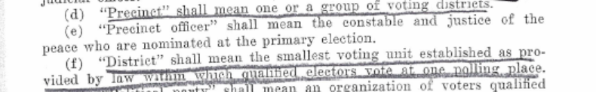

The 1953 definition stated that Districts were subsets of Precincts.

Current law now has Precincts as subsets of Districts:

2013 UTAH CODE:
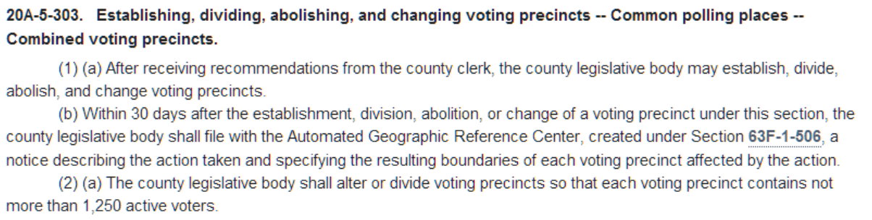

Current election law definitions started to change through a process that began in 1992 with a Working Group that reported to the Utah State Legislature’s State and Local Affairs Interim Committee and culminated in a change in law in 1994 signed by Governor Levitt:

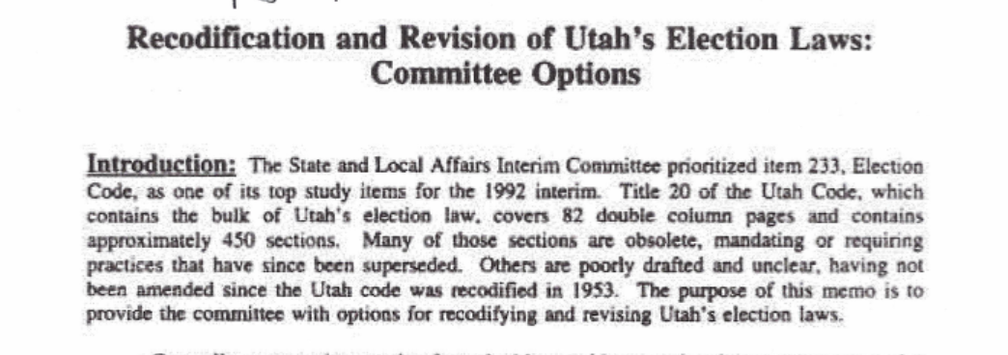

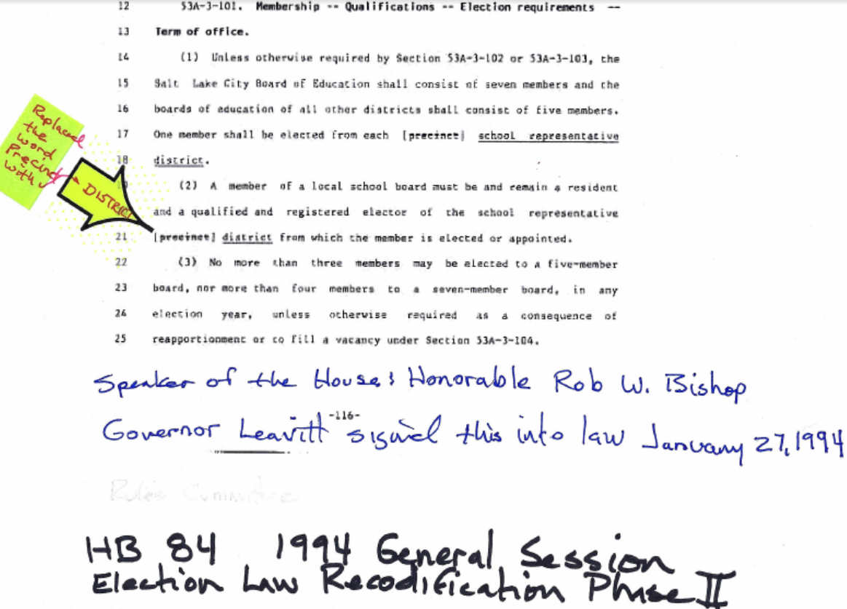

SL County responded to Mr. Clara that the term “precinct” has been historically used and is appropriate within a school district
For some odd reason we are currently are using the 1953 definition, as noted on the previous page, while the law changed in 1994 our practice did not.

The County Clerk’s Office states that PRECINCT is used because that is the information that are receiving from the Superintendent’s Office.

THIS IS FROM UTAH CODE ANNOTATED 1953 VOLUME 5 PAGE 523:
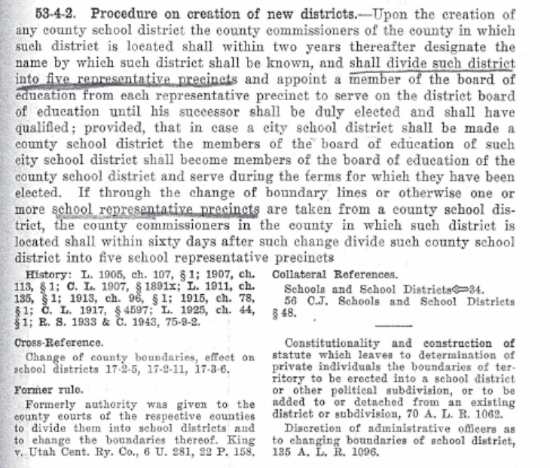

In addition to the emails on page 4 from the County Clerk’s Office, I received this email from County Councilman Wilde. It is an email he received from Jason Rose who is the attorney for the County Council:

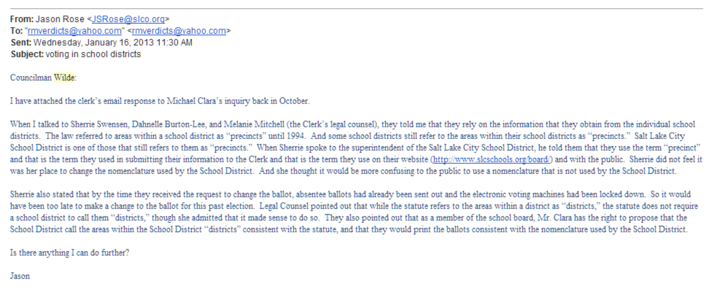

SLC responded to Mr. Clara that they use the term “district” for their city council areas and were not sure why the school district areas are called “precincts”
In our 01/08/2013 Board Meeting, Vice President Heather Bennett stated the following about this issue:

“…the only place it says district is on the map that was created by the city after the redistricting and that is an artifact of the software they were using and the fact that they were in control of the map making process”

Several people in City government dispute that conclusion and all assert they were following state law. They also dispute the conclusion that McKell and Kristi have reached: “…were not sure why the school district areas are called Precincts”.

On the contrary, the City refers to these areas as DISTRICTS in compliance with State Law; there is no uncertainty in their reasoning.

While I received several emails and phone calls from city officials, the following email (with three attachments) from Karan Holladay is the most concise on the matter:

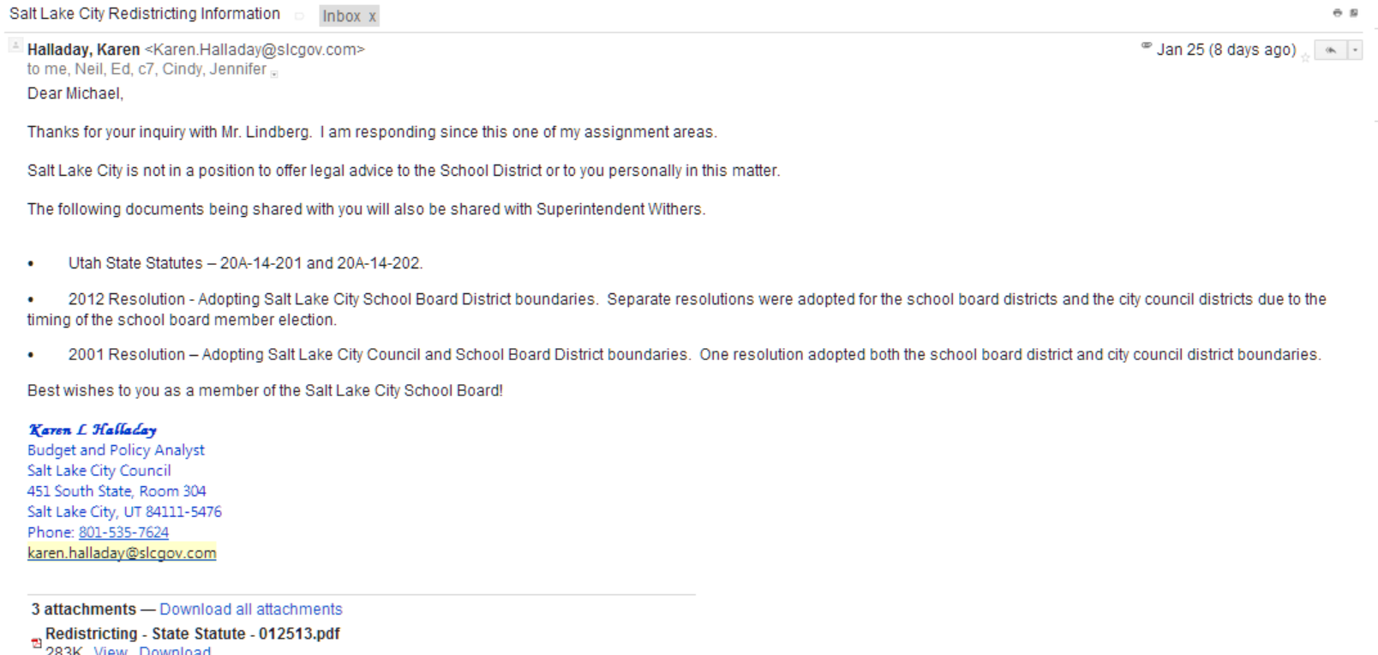
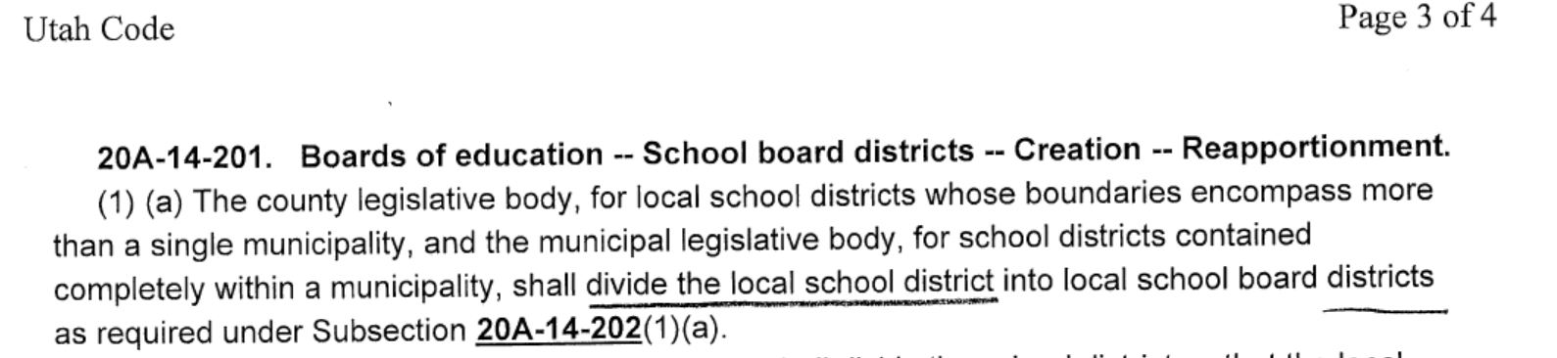
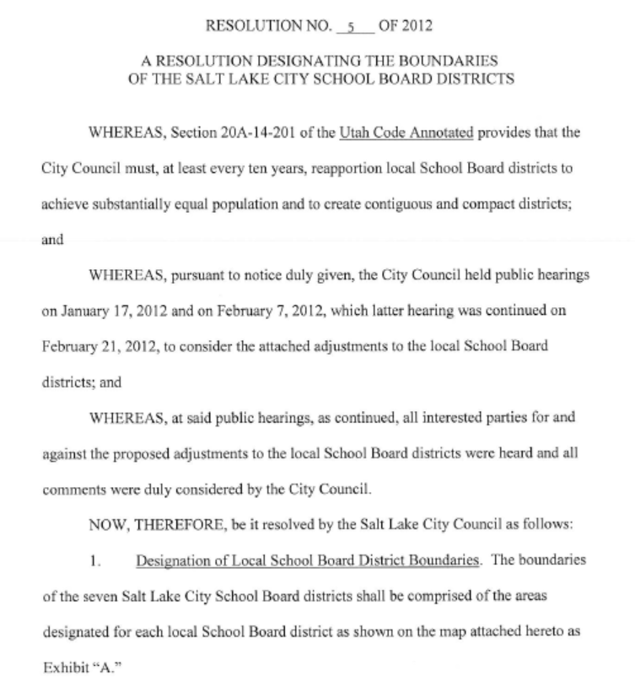

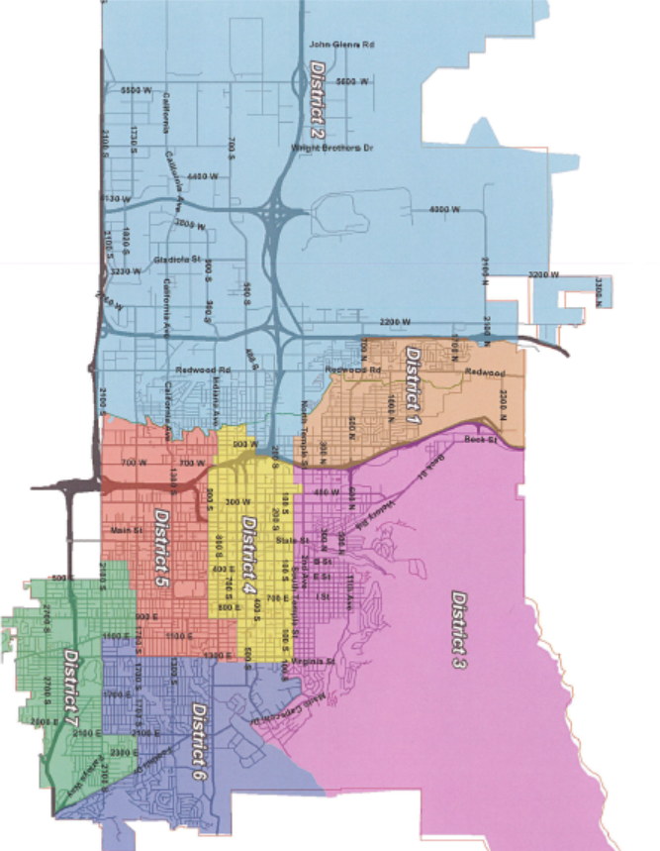

Lt. Governor’s office staff called the superintendents at Mr. Clara’s request and stated that the ballots did say “precinct” and there is no current plan to force a change

As noted on page 1 of this document. Mark Thomas advised me that the Lt. Governor’s Office does not have the authority to compel the county clerk to make the change. Although he has stated to me that the ballot should list us as representing DISTRICTS in compliance with 20A-14-201.

Voting “districts” were changed to voting “precincts” at the state level not too long ago
There was a time when several DISTRICT (s) were subsets of a PRECINCT

Today it is the reverse, at least as far as the law is concerned, “PRECINCT” is now considered the smallest voting unit.

UTAH CODE ANNOTATED 1953 VOLUME 3 PAGE 25:
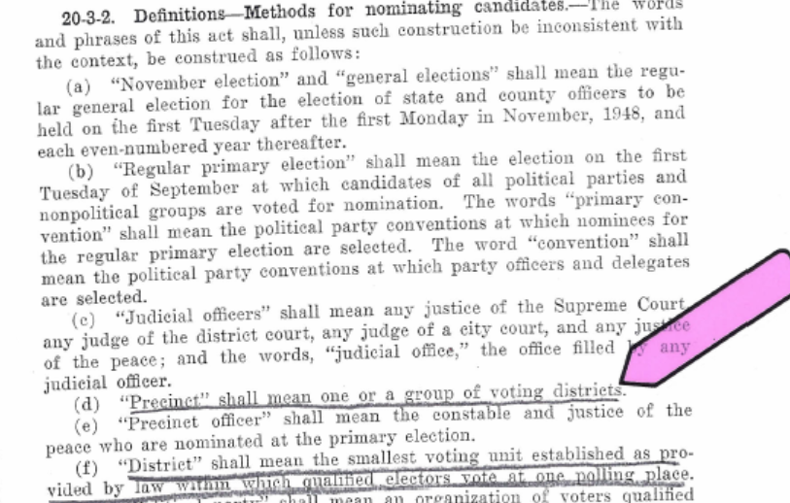

UTAH ELECTION LAWS 2003 Edition page 247
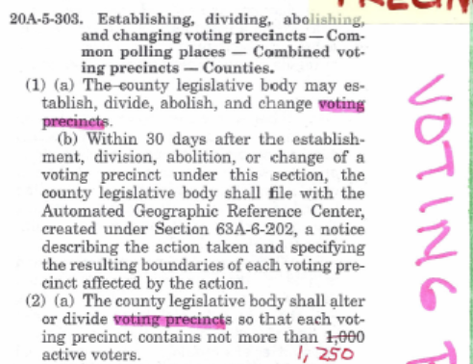

CURRENT LANGUAGE ON PRECINCT:
20A-5-303. Establishing, dividing, abolishing, and changing voting precincts -- Common polling places -- Combined voting precincts.
(1) (a) After receiving recommendations from the county clerk, the county legislative body may establish, divide, abolish, and change voting precincts.
(b) Within 30 days after the establishment, division, abolition, or change of a voting precinct under this section, the county legislative body shall file with the Automated Geographic Reference Center, created under Section 63F-1-506, a notice describing the action taken and specifying the resulting boundaries of each voting precinct affected by the action.
(2) (a) The county legislative body shall alter or divide voting precincts so that each voting precinct contains not more than 1,250 active voters.

